***Young***

***Family Tree***

Horace Henry Young (1859-1913)

m. Elizabeth Harry (1853-1933) m. 1885, South Australia

(1) Florence Ethel Young (1886-1886)

(2) Horace George Young (1887-1921)

m. Adeline Pepper (1883-1951) m. 1907, South Australia

(1) Horace Howard Young (1908-1976)

m. Flora Wainwright Kelly (1910-2007) m. 1932, South Australia

(2) Beryl Florence Young (1909-1975)

m. Douglas William Wallace Crozier (1909-1988) m. 1933, South Australia

(3) Valeska Joyce Young (1912-1990)

m. Sydney James Torr (1908-1989) m. 1937, South Australia

(1) Wendy Torr

(2) Christine Torr

(4) Ross Oliver Young (1918-1984)

(3) Oliver Myrtle Young (1889-1983)

1st m. Clarence William Bazil Donald Loftes (1897-

2nd m. Major General Owen Forbes Phillips (1882-1966)

(4) Max Adolphus Young (1891-1952)

m. Julia May Carroll (1884-1934) m. 1914, South Australia

(1) Max Gerrard Young (1916-1993)

m. Patricia Mary Elwood (1917-1986)

(1) Anthony Joseph Young (1944-1944)

Horace Henry Young

Born – 15th January, 1859, Hare Hatch, Twyford, Berkshire, England (vol 2c/pg386)

Born – registered March quarter, 1859, Wokingham, Berkshire, England (vol 2c/pg386)

Died – 9th July, 1913, Largs Pier Hotel, Largs Bay, South Australia (bk376/122)

Aged – 54 years

Last abode – Largs Pier Hotel, Esplande, Largs Bay

Buried – North Road Cemetery

Occupation – Juryman, Horse Breeder, Racing Horses

Probate - £10,828

Married – 23rd September, 1885, St Luke Church, Adelaide, South Australia (bk144/pg1022)

(groom – 26, single, father – Adolphus Wm Young) (bride – 26, single, father – Richard Harry)

Elizabeth Harry

Born – 9th December, 1853, Adelaide, South Australia (bk4/pg256)

Died – 29th September, 1933, Glenelg, South Australia (bk551/pg467)

Aged – 75 years

Buried – North Road Cemetery

Probate - £20,147

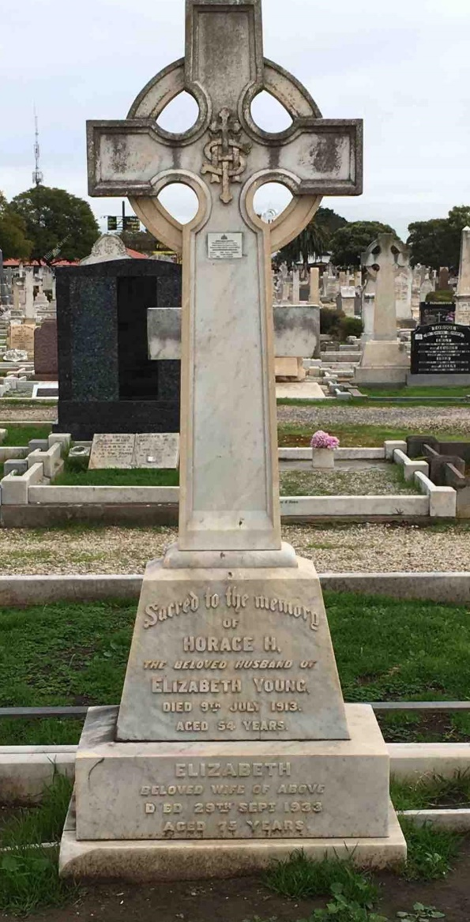 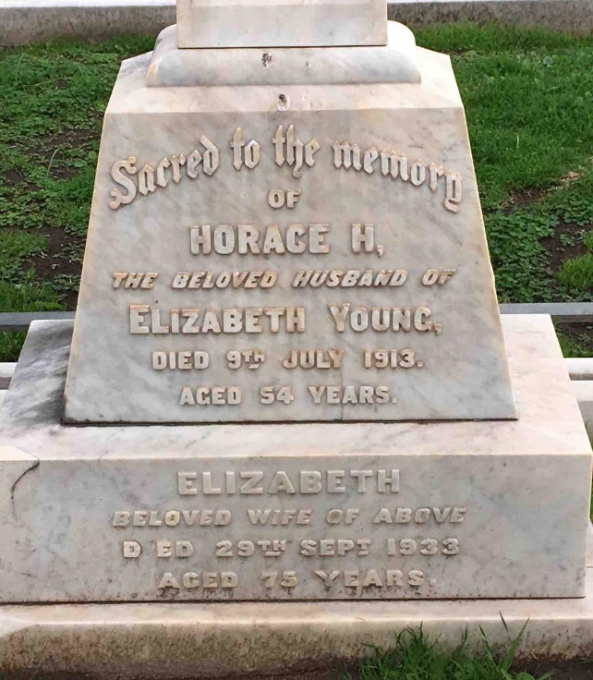

***Newspaper clipping***

***Evening Journal, dated Monday 4th February, 1889***

**TENDERS**

TENDERS are invited until noon of February 9 for additions and alterations to the residence of Horace H. Young, Esq., at Edwardstown.

No Tender necessarily accepted.

Plans and specifications at my office

ALEX W. MURRAY, Architect

Morialta Chambers, Victoria-square.

***The Express and Telegraph, dated Wednesday 5th February, 1890***

FOR SALE near Edwardstown, the superior Residence of Horace H. Young, Esq., 3 ½ miles from the city, being part section 54, containing 10 acres of excellent land. The residence contains nine large and lofty rooms, two cellars, conservatory, shadehouse, stables, coachhouse, three loose boxes. Land nicely laid out and planted; young orchard with every kind of fruit; nice flower garden; water laid on throughout the garden. All in first-class order.

If not sold privately will be sold by auction early in April.

Cards to view on application to John Milne, Auctioneer, 37 Exchange, Pirie-street.

***Evening Journal, dated Friday 21st November, 1890***

HANDY MAN as Groom and Gardener, willing to make himself useful. Horace H. Young, Edwardstown, in the morning.

***South Australian Register, dated Saturday 3rd February, 1894***

FOR ABSOLUTE SALE

Under instructions from Horace H. Young, Esq.,

EDWARDSTOWN – PART SECTION NO. 54, containing 10 acres of first-class land, on which is erected a very substantial residence of nine large and lofty rooms, two cellars, conservatory, shadehouse, stables, coachhouse, three loose boxes. Land nicely laid out and planted; orchard with every kind of fruit; nice flower garden. Water laid on throughout the gardens. All in excellent order.

***Chronicle, dated Saturday 12th December, 1896***

Mr Horace. H. Young writes to us from Edwardstown under date December 11 as follows:- Will you kindly let the public know that neither myself nor my trainer has nominated my horse ‘My Novel’ for the forth coming Port Adelaide races, nor have I authorised anyone else to do so – H.H.Y.

***The Register, dated Friday 29th January, 1909***

Next Tuesday, February 2, at 11

At our mart, Industrial Buildings

Instructed by Horace H. Young, Esq., (who is leaving South Australia)

JOHNSON & COMPANY

Will sell without reserve

The whole of Mr. H.H. Young’s magnificent furniture (removed to our mart from Edwardstown for greater convenience of sale).

Catalogues will be prepared.

***The Express and Telegraph, dated Thursday 10th July, 1913***

**DEATHS**

**YOUNG** – On the 9th July, at Largs Pier Hotel, Horace Henry Young, of Hare Hatch, Twyford, Berkshire (England), aged 54 years

***Advertiser, SA, dated Friday 11th July, 1913***

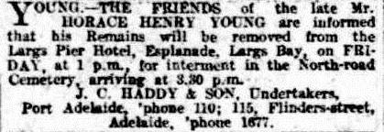

***Observer, SA, dated Saturday 19th July, 1913***

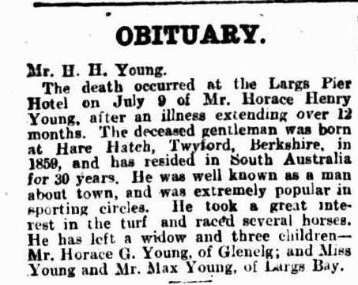

***Observer, dated Saturday 19th July, 1913***

In the death of Mr Horace H. Young, which occurred at Largs Bay on July 8 after a long illness, the turf has lost one of its old-time supporters, who up to the time of his demise had never lost interest in the pastime. Mr Young, who was born at Hare Hatch, Twyford, Berkshire, England, in 1859, came out to South Australia about 30 years ago, and soon evinced a liking for racing. His colours were carried on the local turf by Parasite (The Vagabond – Stella), Go-ahead (Gang Forward – Rivalry), My Novel (Emulation – Novelist), and Vagary (The Vagabond – Lusitania). The last named was killed at Morphettville on June 22, 1891, while running in a youngsters race, and C. J. Parker, who had the mount, also met his death. Vagary had won the Disposal Stakes on the same afternoon.

***The Advertiser, dated Monday 2nd October, 1933***

**DEATHS**

**YOUNG** – On the 29th September, at Glenelg, Elizabeth, widow of Horace Henry Young, and beloved mother of Max and Olive. Late of Edwardstown.

***News, SA, dated Monday 16th October, 1933***

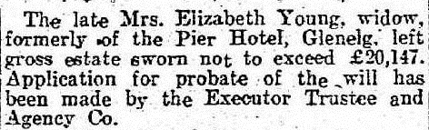

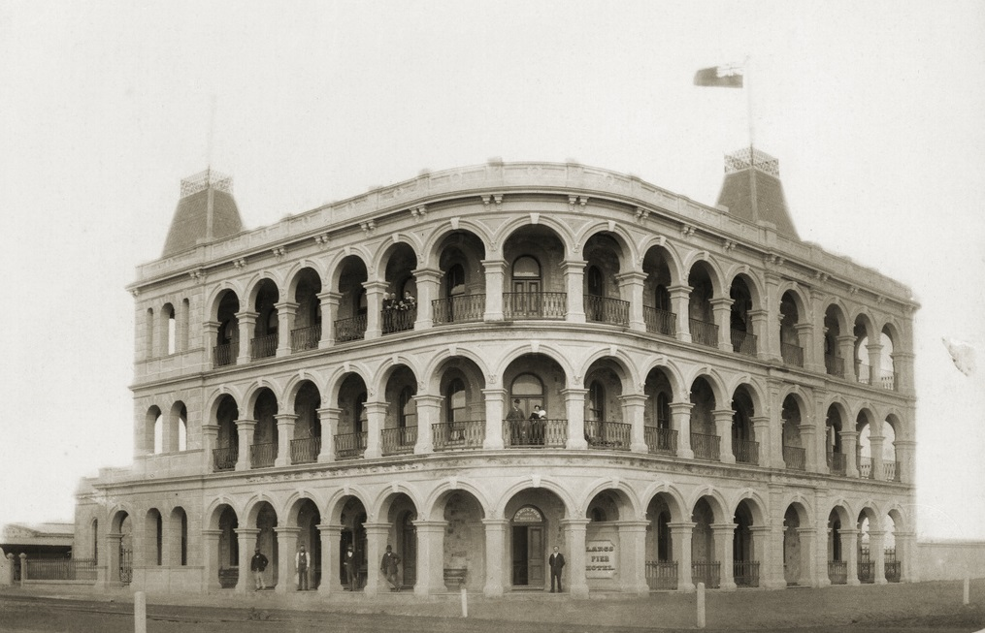

Largs Pier Hotel, c. 1884

[General description – SLSA] Constructed by the Largs Bay Land and Investment Company in 1882, this three-storied, white arched building was built of stone with rendered masonry. The architects were Ernest H. Bayer and Latham A. Whithall. Its roof feathers two cupolas topped with widow’s walks designed for watching ships. People posing for the photographer in front of the hotel and on its balconies were probably the hotel manager’s family and staff. [SLSA B3722]

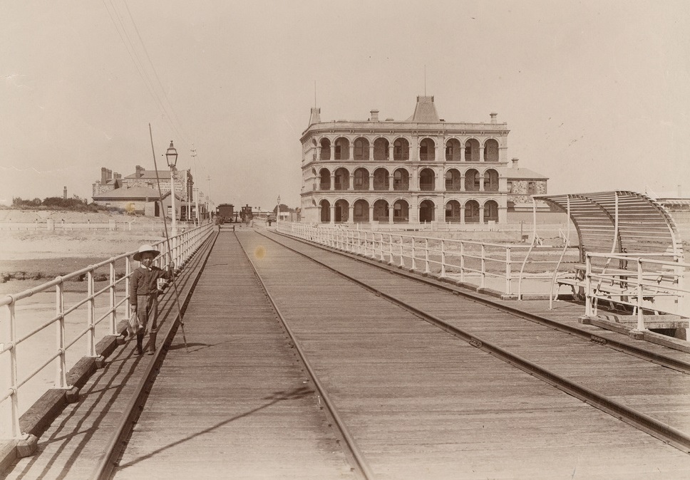

[Description – SLSA] – The Largs Pier Hotel at Largs Bay opened in 1882 the same day as the Largs Bay Railway and Pier. From 1882 until about 1892 the Largs Pier was the primary port of call for migrants arriving from Europe.

[SLSA B12544]

1. Florence Ethel Young

Born – 16th March, 1886, Adelaide, South Australia (bk370/pg372)

Died – 9th December, 1886, Edwardstown, South Australia (bk159/pg227)

Aged – 8 months

Buried – St Mary’s Mitcham Cemetery

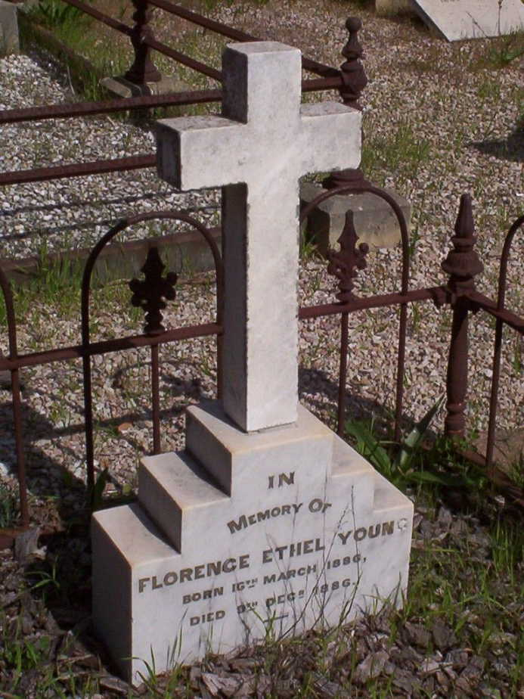

1. Horace George Young

Born – 12th July, 1887, Edwardstown, South Australia (bk398/pg144)

Died – 28th April, 1921, Glenelg, South Australia (bk445/pg379)

Aged – 33 years

Cause of death – Appendicitis

Buried – St Jude’s Cemetery, Brighton

Occupation – Mayor of Brighton

Probate - £62,000

Married – 12th November, 1907, St Mary Magdalene Parsonage, Adelaide, South Australia (bk233/pg992)

(groom – 22, single) (bride – 23, single, father – Frederick John Pepper)

Adeline Pepper

Born – 27th September, 1883, Hilton, South Australia (bk313/pg211)

Died – 30th June, 1951, Glenelg, South Australia (bk770/pg3511)

Aged – 66 years

Buried – St Jude’s Cemetery, Brighton

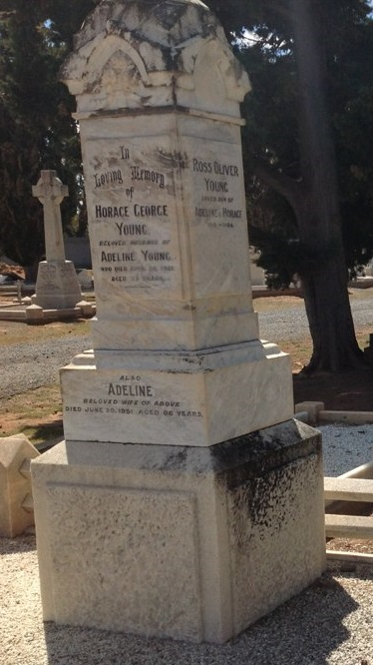

***Newspaper clippings***

***The Express and Telegraph, SA, dated Thursday 28th April, 1921***

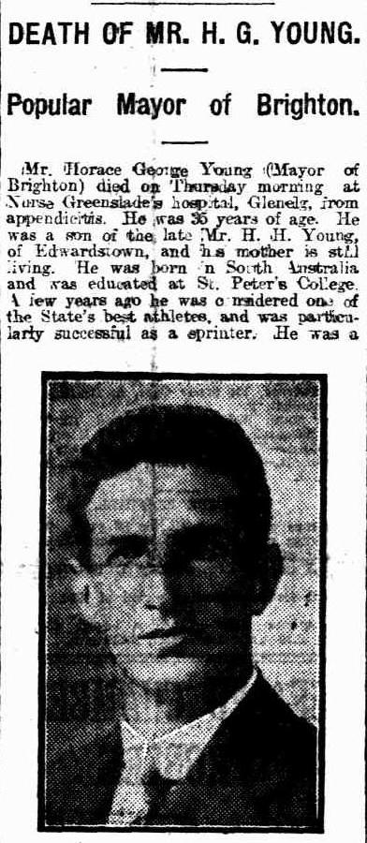 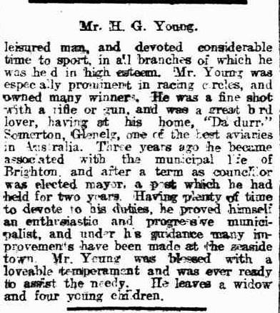

***The Journal, SA, dated Monday 14th May, 1923***

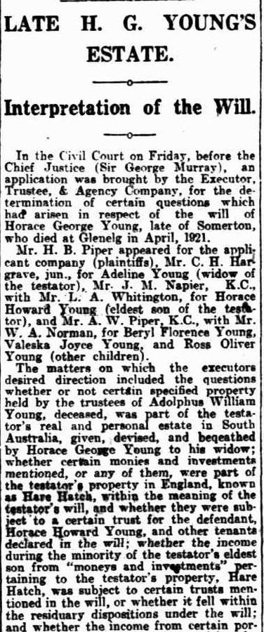 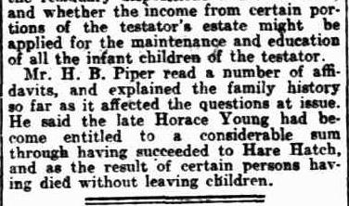

***The Advertiser, SA, dated Wednesday 4th July, 1951***

**DEATH**

**YOUNG** – On June 30, at the private hospital, Adeline, beloved wife of the late Horace George Young, and loving mother of Mick, Beryl, Valeska and Ross.

1. Horace Howard Young

Born – 2nd February, 1908, Adelaide, South Australia (bk797/pg169)

Died – 6th November, 1976, Brighton, South Australia

Aged – 68 years

Buried – Centennial Park Cemetery, Cremated

Buried – St Jude’s Cemetery, Brighton (with parents)

Married – 16th April, 1932, St Peters Church, Glenelg, South Australia (bk331/pg205)

(groom – 24, single) (bride – 22, single, father – John George Kelly)

Flora Wainwright Kelly

Born – 2nd June, 1910, McLaren Vale, South Australia (bk844/pg240)

Died – 2007

Aged – 97 years

Buried – St Jude’s Cemetery, Brighton

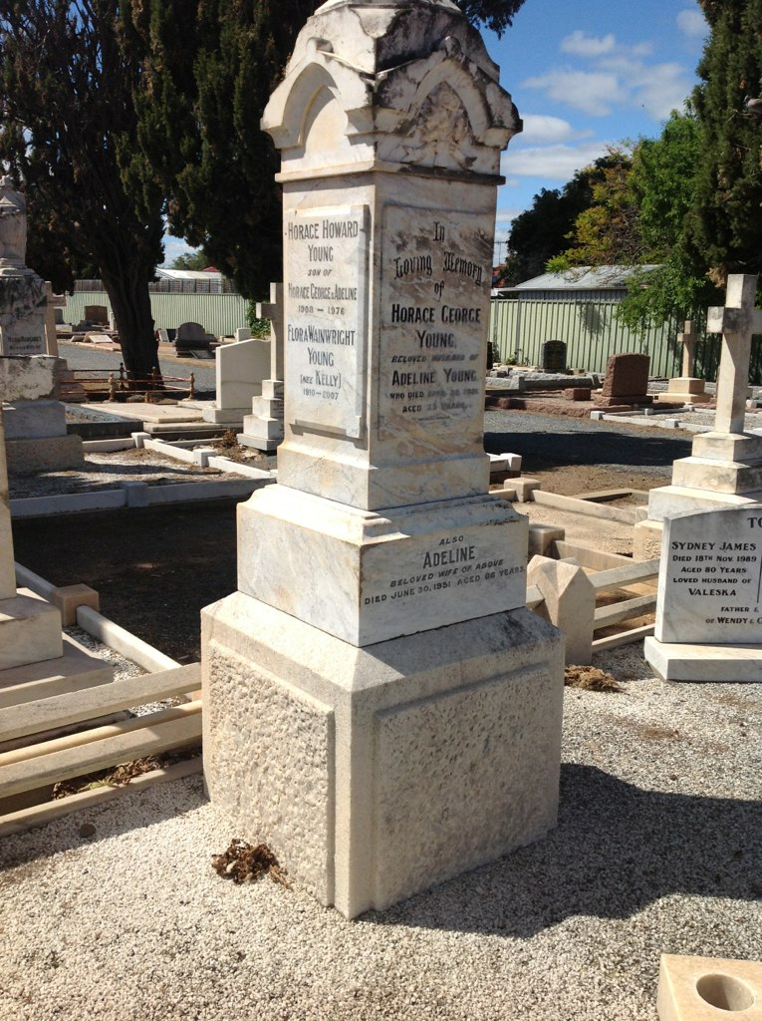

***Newspaper clippings***

***The Advertiser, SA, dated Thursday 21st April, 1932***

**YOUNG – KELLY**

On Saturday afternoon, in the Memorial Chapel, St. Peter’s church, Glenelg, the marriage was celebrated of Horace Howard, elder son of Mrs and the late Horace George Young, of Seawall, Glenelg, to Flora Wainwright, elder daughter of Mr and Mrs J. G. Kelly, of Seafield Tower, Glenelg. The bride, who was given away by her father, was gowned in saxe blue crepe de chine, and carried a bouquet of shell pink carnations. She wore a pearl pendant, the gift of her mother. The Rev. H. R. Cavalier officiated. Only close relatives of the bride and bridegroom were present.

1. Beryl Florence Young

Born – 13th July, 1909, Adelaide, South Australia (bk825/pg404)

Died – 2nd November, 1975, South Australia

Aged – 66 years

Buried – Centennial Park Cemetery, location – Painter Court, Wall 207, niche L021

Married – 18th April, 1933, St Peters College, Hackney, South Australia (bk338/pg450)

(groom – 24, single, father – Wm Douglas Crozier) (bride – 23, single)

Douglas William Wallace Crozier

Born – 10th April, 1909, Wentworth, New South Wales (reg.no. 20608)

Died – 5th March, 1988, Keith, South Australia

Aged – 78 years

Buried – Centennial Park Cemetery, location – Painter Court, Wall 207, niche L021

Occupation - Grazier

***Military Service***

***Service – WW2, Royal Australian Navy***

***Service No.***

Date of Enlistment – 10th August, 1942, Adelaide

Next of kin – Beryl Crozier

Date of Discharge – 16th March, 1956

Rank – Lieut. Commander

Posting at Discharge – HMAS Torrens

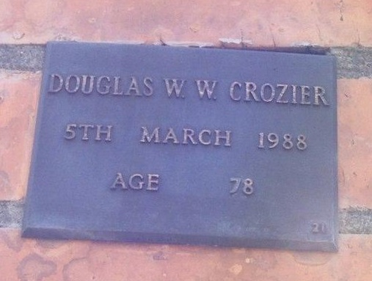 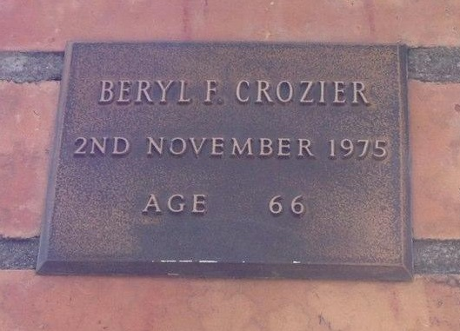

1. Valeska Joyce Young

Born – 29th January, 1912, Mile End, South Australia (bk879/pg262)

Died – 22nd March, 1990, South Australia

Aged – 78 years

Buried – St Jude’s Cemetery, Brighton

Married – 29th May, 1937, St Peters Church, Glenelg, South Australia (bk378/pg2199)

(groom – 28, single, father – Sydney Torr) (bride – 25, single)

Sydney James Torr

Born – 29th December, 1908, Mintaro, South Australia (bk815/pg142)

Died – 18th November, 1989, South Australia

Aged – 81 years

Buried – St Jude’s Cemetery, Brighton

Occupation – Clerk

***Military Service***

***Service – WW2, Australian Army***

***Service No. S66357***

Date and locality of enlistment – 12th April, 1942, Glenelg, South Australia

Place of enlistment – Adelaide

Next of kin – Valeska Torr

Date of discharge – 11th September, 1944

Rank - Private

1. Wendy Torr
2. Christine Torr

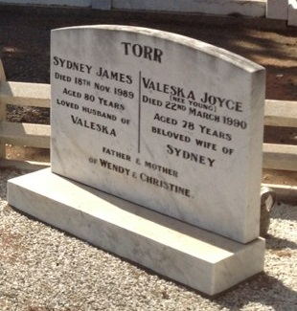

1. Ross Oliver Young

Born – 23rd January, 1918, Somerton, South Australia (bk13A/pg88)

Died – 18th September, 1984, Kingston Park, South Australia

Aged – 66 years

Buried – Centennial Park Cemetery, cremated

Buried – St Jude’s Cemetery, Brighton

***Military Service***

***Service – WW2, Australian Army***

***Service No. SX24835 (S20088)***

Date and locality of enlistment – 7th August, 1942, Glenelg, South Australia

Place of enlistment – Alice Springs, Northern Territory

Next of kin – Adeline Young

Date of discharge – 10th April, 1946

Rank – Driver

Posting at discharge – 148 General Transport Company



1. Olive Myrtle Young

Born – 2nd August, 1889, Edwardstown, South Australia (bk445/pg152)

Died – 12th October, 1983, Toorak-Prahran, Melbourne, Victoria (reg.no. 25602)

Aged – 94 years

Buried – Cheltenham Cemetery, Victoria

1st marriage

Married – 8th November, 1920, Sydney, NSW (reg.no. 15362) (divorced – 1921-1929)

Clarence William Bazil Donald Loftes

Born – 12th April, 1897, Morchard, South Australia (bk602/pg229)

Occupation – Aeronautical Engineer

Crime – 1922, tried at Supreme Court, Adelaide, on 2nd May, 1921, for forgery and uttering; two years hard labor; native of South Australia, born 1896, 5ft 9in high, dark complexion, dark hair, dark eyes, straight nose, good mouth, medium chin, three vaccines left arm, scar on both shins. Freedom due 25th September, 1922.

(from the Police Gazette)

***Military Service***

***Service – WW1, AIF***

***Service No. 32497***

Religion – Church of England

Occupation – Bank Teller

Address – National Bank, Mt Barker, SA

Marital status – single

Age at embarkation – 23 years

Next of kin – father, W. Loftes, PO Port Augusta, SA

Enlistment – 23rd September 1916

Rank – Gunner

Unit – 6th Field Artillery Brigade, Reinforcement 13

Rank from Nominal Roll – Lieutenant

Returned to Australia – 16th June, 1919

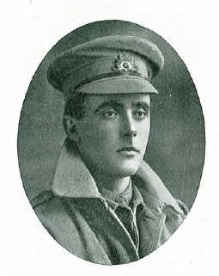

2nd marriage

Married – 4th December, 1929, Scots Church, North Terrace, Adelaide, South Australia (bk321/pg787)

(groom – 27, single, father – Arthur Owen Henry Phillips) (bride – 37, divorced)

Major General Owen Forbes Phillips CMG., DSO.

Born – 9th June, 1882, Warwick, Queensland

Died – 15th May, 1966, Beaumaris, Victoria

Aged – 83 years

Buried – Cheltenham Cemetery, Victoria

Occupation – Permanent Military Forces - Soldier - retired 15th June, 1942

Service No. - B2455

Medals – American Distinguished Service Medal; Most Distinguished Order of Saint Michael and Saint George, for services rendered in connexion with military operations in France and Flanders

More information about Owen Forbes Phillips - <https://adb.anu.edu.au/biography/phillips-owen-forbes-8039>

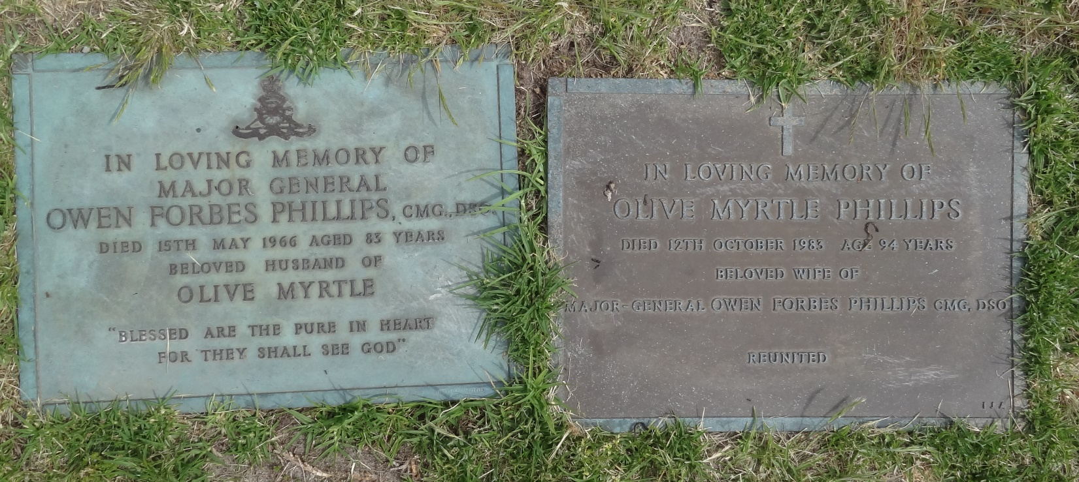

**(Source – www. generals.dk)**

**Phillips, Owen Forbes**

**Major-General**

**\* 9th of June 1882**

**† 15th of May 1966**

**Promotions**

|  |  |
| --- | --- |
| 1917-09-24 | Brevet Lieutenant-Colonel |
| 1917-10-08 | Granted the Honorary rank of Brigadier-General |
| 1920-01-01 | Lieutenant. Colonel |
| 1921-05-01 | Temporary Colonel |
| 1922-07-31 | Relinquishes the Temporary rank of Colonel |
| 1928-03-20 | Temporary Colonel Commandant |
| 1929-01-03 | Temporary Brigadier |
| 1936-07-01 | Major-General |

**Service**

|  |  |  |  |
| --- | --- | --- | --- |
| 1916-03-12 | – | 1917-10-07 | Commanding Officer 14th Australian Field Artillery Brigade [Middle East - France] |
| 1917-10-08 | – | 1919-08-18 | Commander Royal Artillery, 2nd Australian Infantry Division [France] |
| 1919-09-01 | – | 1921-04-30 | Chief Instructor at the School of Gunnery |
| 1921-05-01 | – | 1922-07-31 | Commander Royal Artillery, 1st Australian Infantry Division |
| 1922-08-01 | – | 1923-09-30 | Staff Officer, A-Q Branch, 1st Australian Cavalry Division |
| 1923-10-01 | – | 1924-12-31 | Chief Instructor at Artillery Schools of Instruction |
| 1924-06-02 | – | 1929-01-31 | Aide-de-Camp to the Governor-General of Australia |
| 1925-01-01 | – | 1926-04-30 | Assistant Adjutant & Quartermaster-General, 1st Australian Cavalry Division |
| 1926-05-01 | – | 1929-11-30 | Commanding Officer Field Troops, 4th Military District |
| 1926-05-01 | – | 1929-11-30 | Temporary District Officer Commanding 4th Military District |
| 1929-12-01 | – | 1933-01-31 | Director of Ordnance Service, Army Headquarters |
| 1933-02-01 | – | 1934-07-10 | General Officer Commanding 1st Australian Division |
| 1933-02-01 | – | 1934-07-10 | Temporary District Officer Commanding 2nd Military District |
| 1934-07-11 | – | 1938-09-14 | Quartermaster-General, Army Headquarters |
| 1934-07-11 | – | 1939-10-12 | Third Military Member of the Military Board |
| 1934-11-08 | – |  | Honorary Colonel, 1st Armoured Cavalry Regiment |
| 1938-09-15 | – | 1939-10-12 | Quartermaster-General of the Ordnance, Army Headquarters |
| 1939-10-13 | – | 1941-06-09 | Inspector-General of Anti-Aircraft & Coastal Defences, Army Headquarters |
| 1941-06-09 | – |  | Unemployed List |
| 1942-XX-XX |  |  | Military Consultant, Army Inventions Directorate |
| 1942-06-09 |  |  | Retired |

1. Max Adolphus Young

Born – 30th May, 1891, Edwardstown, South Australia (bk480/pg307)

Died – 19th November, 1952, North Adelaide, South Australia (bk790/pg6324)

Aged – 61 years

Last abode – Glenelg

Last abode – 17 Partridge street, Glenelg

Married – 2nd December, 1914, Catholic Presbytery, Brompton, South Australia (bk261/pg599)

(groom – 24, single) (bride – 29, single, father – Michael Carroll)

Julia May Carroll

Born – 8th May, 1884, Adelaide, South Australia (bk326/pg319)

Died – 17th July, 1934, Glenelg, South Australia (bk560/pg2982)

Aged – 49 years

Buried – West Terrace Cemetery

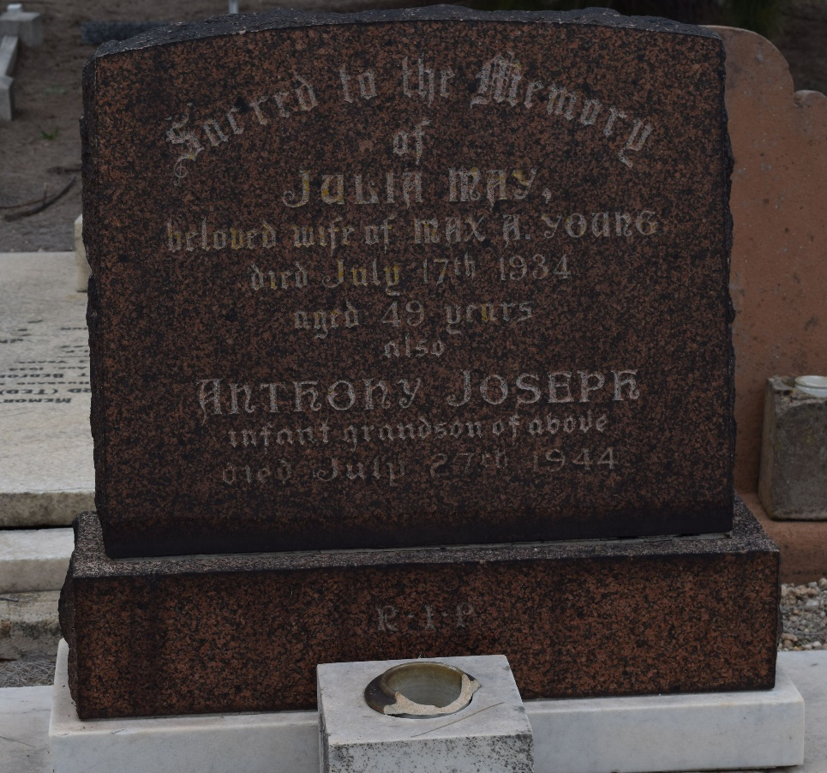

1. Max Gerrard Young

Born – 2nd May, 1916, Glenelg, South Australia (bk977/pg558)

Died – 8th June, 1993, Glandore, South Australia

Aged – 77 years

Buried – West Terrace Cemetery

***Military Service***

***Service – WW2, Royal Australian Navy***

***Service No. PA/V201***

Date and Port of Enlistment – 13th July, 1942, Port Adelaide

Next of kin – Patricia

Date of discharge – 1st July, 1946

Rank – LDG SMN

Posting at discharge – HMAS Torrens

Married – c. 1940

Patricia Mary Elwood

Born – 21st November, 1917, Goodwood, South Australia (bk8a/pg595)

Died – 11th January, 1986, Adelaide, South Australia

Aged – 68 years

Buried – Centennial Park Cemetery

1. Anthony Joseph Young

Born – 27th July, 1944, North Adelaide, South Australia

Died – 27th July, 1944, North Adelaide, South Australia (bk678/pg3374)

Aged – 10 hours

Buried – West Terrace Cemetery with his grandmother (Julia)

Last abode - Glenelg